cURL
# Source: AI Source: Provided by: [Data Path: Persons Table -> ID Column: 1, Name_En Column: Motasem Essam] -> From: [ChatGPT] on [1/19/2026]
cURL (pronounced like “curl”) is a command-line tool and library for transferring data with URLs. It's widely used to interact with web servers, APIs, and other networked resources. The name stands for "Client for URLs."

🔧 What It Does:
# Source: AI Source: Provided by: [Data Path: Persons Table -> ID Column: 1, Name_En Column: Motasem Essam] -> From: [ChatGPT] on [1/19/2026]
cURL lets you send and receive data over various protocols such as:
- HTTP / HTTPS
- FTP / FTPS
- SFTP
- SCP
- SMTP / POP3 / IMAP
- And more...

✅ Common Use Cases:
# Source: AI Source: Provided by: [Data Path: Persons Table -> ID Column: 1, Name_En Column: Motasem Essam] -> From: [ChatGPT] on [1/19/2026]
- Testing APIs
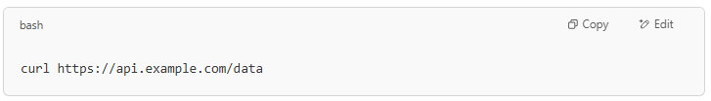
curl https://api.example.com/data

- Sending data via POST
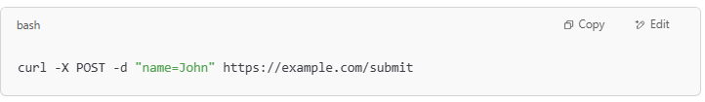
curl -X POST -d "name=John" https://example.com/submit

- Adding headers
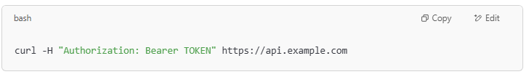
curl -H "Authorization: Bearer TOKEN" https://api.example.com

- Downloading files
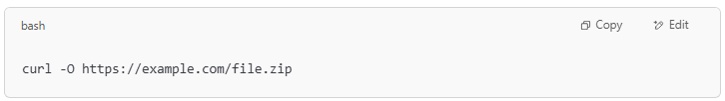
curl -O https://example.com/file.zip

- Uploading files
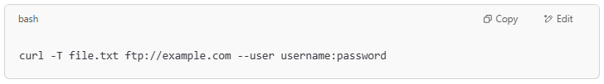
curl -T file.txt ftp://example.com --user username:password

💡 Technical Notes:
# Source: AI Source: Provided by: [Data Path: Persons Table -> ID Column: 1, Name_En Column: Motasem Essam] -> From: [ChatGPT] on [1/19/2026]
- cURL is powered by libcurl, a free and open-source URL transfer library.
- It's cross-platform and available on Linux, macOS, and Windows.

Let me know if you want examples tailored to a specific use case (e.g. working with a REST API, downloading files, etc.).

is used for rest or soap or GraphQL
# Source: AI Source: Provided by: [Data Path: Persons Table -> ID Column: 1, Name_En Column: Motasem Essam] -> From: [ChatGPT] on [1/19/2026]
Great question! cURL itself is protocol-agnostic—it works with any kind of web service or API as long as it uses supported protocols like HTTP/HTTPS. So:
- You can use cURL with REST APIs
REST APIs typically use HTTP methods like GET, POST, PUT, DELETE, and cURL can send those requests easily.
- You can use cURL with SOAP APIs
SOAP APIs usually communicate via XML over HTTP, and cURL can send the necessary XML payload in POST requests with proper headers.
- You can use cURL with GraphQL APIs
GraphQL typically uses POST requests with a JSON body containing the query, which cURL can also handle.

Summary:
# Source: AI Source: Provided by: [Data Path: Persons Table -> ID Column: 1, Name_En Column: Motasem Essam] -> From: [ChatGPT] on [1/19/2026]
API Type | Use with cURL? | Notes
REST | Yes | Straightforward HTTP requests with JSON payloads or query params
SOAP | Yes | Requires sending XML in POST body, setting Content-Type headers
GraphQL | Yes | Usually POST requests with JSON body containing query/mutation

Example snippets:
# Source: AI Source: Provided by: [Data Path: Persons Table -> ID Column: 1, Name_En Column: Motasem Essam] -> From: [ChatGPT] on [1/19/2026]
- REST (GET)
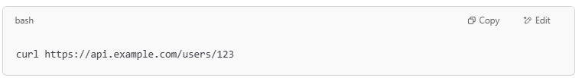
curl https://api.example.com/users/123

- SOAP (POST with XML)
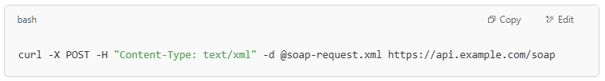
curl -X POST -H "Content-Type: text/xml" -d @soap-request.xml https://api.example.com/soap

- GraphQL (POST with JSON query)
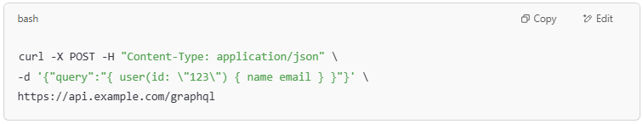
curl -X POST -H "Content-Type: application/json" \
-d '{"query":"{ user(id: \"123\") { name email } }"}' \
https://api.example.com/graphql

?

curl with rest
# Source: AI Source: Provided by: [Data Path: Persons Table -> ID Column: 1, Name_En Column: Motasem Essam] -> From: [ChatGPT] on [1/19/2026]
Learning cURL with REST APIs is a super useful skill — it lets you test and interact with APIs right from your terminal.
Let’s break it down step-by-step with simple examples:

1. GET Request — Fetch Data
# Source: AI Source: Provided by: [Data Path: Persons Table -> ID Column: 1, Name_En Column: Motasem Essam] -> From: [ChatGPT] on [1/19/2026]
This is the most basic: you request data from an API.
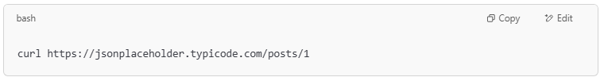
curl https://jsonplaceholder.typicode.com/posts/1

- This fetches the post with ID 1 from a sample REST API.
- The response will be JSON data printed in your terminal.

2. GET Request with Headers
# Source: AI Source: Provided by: [Data Path: Persons Table -> ID Column: 1, Name_En Column: Motasem Essam] -> From: [ChatGPT] on [1/19/2026]
Sometimes APIs require headers, like authentication tokens.
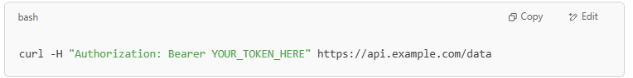
curl -H "Authorization: Bearer YOUR_TOKEN_HERE" https://api.example.com/data

-H adds headers.

3. POST Request — Send Data
# Source: AI Source: Provided by: [Data Path: Persons Table -> ID Column: 1, Name_En Column: Motasem Essam] -> From: [ChatGPT] on [1/19/2026]
Sending data to the server, usually to create a resource.
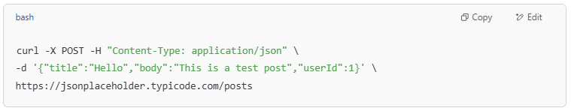
curl -X POST -H "Content-Type: application/json" \
-d '{"title":"Hello","body":"This is a test post","userId":1}' \
https://jsonplaceholder.typicode.com/posts

- -X POST means we’re sending a POST request.
- -H "Content-Type: application/json" tells the server we’re sending JSON.
- -d sends the JSON data as the request body.

4. PUT Request — Update Data
# Source: AI Source: Provided by: [Data Path: Persons Table -> ID Column: 1, Name_En Column: Motasem Essam] -> From: [ChatGPT] on [1/19/2026]
Replace existing data with new data.
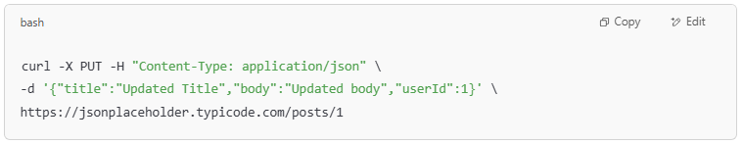
curl -X PUT -H "Content-Type: application/json" \
-d '{"title":"Updated Title","body":"Updated body","userId":1}' \
https://jsonplaceholder.typicode.com/posts/1

5. DELETE Request — Remove Data
# Source: AI Source: Provided by: [Data Path: Persons Table -> ID Column: 1, Name_En Column: Motasem Essam] -> From: [ChatGPT] on [1/19/2026]
Delete a resource by ID.
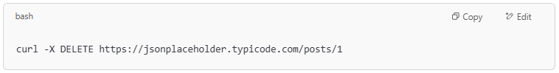
curl -X DELETE https://jsonplaceholder.typicode.com/posts/1

Handy cURL Flags:
# Source: AI Source: Provided by: [Data Path: Persons Table -> ID Column: 1, Name_En Column: Motasem Essam] -> From: [ChatGPT] on [1/19/2026]
Flag | Purpose
-X | Specify HTTP method (GET, POST, etc.)
-H | Add HTTP header
-d | Send data in the request body
-i | Include response headers in output
-v | Verbose mode — detailed info about request and response
-o filename | Save output to a file

Want to try?
# Source: AI Source: Provided by: [Data Path: Persons Table -> ID Column: 1, Name_En Column: Motasem Essam] -> From: [ChatGPT] on [1/19/2026]
Great! Let's walk through a mini interactive tutorial using a free fake REST API so you can safely test cURL commands.
We’ll use:
🔗 https://jsonplaceholder.typicode.com — a free REST API for testing.

✅ Step 1: GET a post
# Source: AI Source: Provided by: [Data Path: Persons Table -> ID Column: 1, Name_En Column: Motasem Essam] -> From: [ChatGPT] on [1/19/2026]
Command:
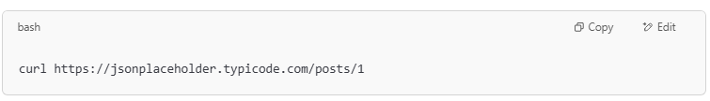
curl https://jsonplaceholder.typicode.com/posts/1

What it does:
Fetches the post with ID 1. Try running it in your terminal!

✅ Step 2: POST a new post
# Source: AI Source: Provided by: [Data Path: Persons Table -> ID Column: 1, Name_En Column: Motasem Essam] -> From: [ChatGPT] on [1/19/2026]
Command:
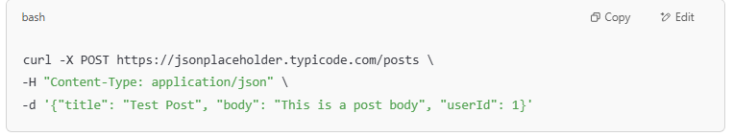
curl -X POST https://jsonplaceholder.typicode.com/posts \
-H "Content-Type: application/json" \
-d '{"title": "Test Post", "body": "This is a post body", "userId": 1}'

What it does:
Sends a new post to the server. The API will return the newly "created" resource.

✅ Step 3: PUT to update a post
# Source: AI Source: Provided by: [Data Path: Persons Table -> ID Column: 1, Name_En Column: Motasem Essam] -> From: [ChatGPT] on [1/19/2026]
Command:
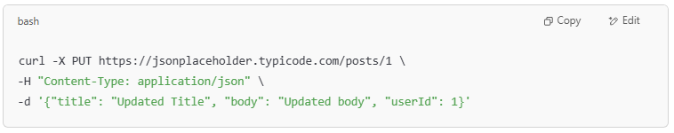
curl -X PUT https://jsonplaceholder.typicode.com/posts/1 \
-H "Content-Type: application/json" \
-d '{"title": "Updated Title", "body": "Updated body", "userId": 1}'

What it does:
Replaces the content of post 1.

✅ Step 4: DELETE a post
# Source: AI Source: Provided by: [Data Path: Persons Table -> ID Column: 1, Name_En Column: Motasem Essam] -> From: [ChatGPT] on [1/19/2026]
Command:
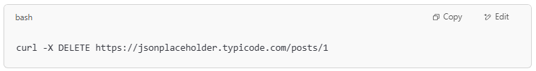
curl -X DELETE https://jsonplaceholder.typicode.com/posts/1

What it does:
Sends a delete request to remove post 1.

💡 Tips:
# Source: AI Source: Provided by: [Data Path: Persons Table -> ID Column: 1, Name_En Column: Motasem Essam] -> From: [ChatGPT] on [1/19/2026]
- You can use -v for verbose output to see headers:
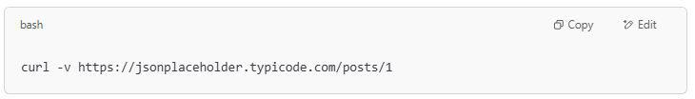
curl -v https://jsonplaceholder.typicode.com/posts/1

- You can save the response to a file with -o:
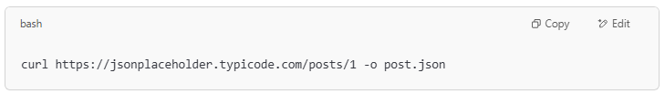
curl https://jsonplaceholder.typicode.com/posts/1 -o post.json

SOAP with rest
# Source: AI Source: Provided by: [Data Path: Persons Table -> ID Column: 1, Name_En Column: Motasem Essam] -> From: [ChatGPT] on [1/19/2026]
It looks like you're asking about SOAP with REST, but these are two different web service architectures, so let me clear up the confusion and explain how they relate:

🔄 SOAP vs. REST: What’s the Difference?
# Source: AI Source: Provided by: [Data Path: Persons Table -> ID Column: 1, Name_En Column: Motasem Essam] -> From: [ChatGPT] on [1/19/2026]
Feature | SOAP | REST
Protocol | Strict protocol using XML | Architectural style using HTTP
Data Format | XML only | JSON (usually), but also XML, etc.
Message Style | Envelopes, headers, bodies | Simple URLs and HTTP methods
Operations | Defined via WSDL | Standard HTTP verbs (GET, POST...)
Transport | Usually HTTP, but also SMTP, etc. | Always HTTP/S
Complexity | Heavier, more rigid | Lightweight and flexible

✅ Can SOAP and REST Work Together?
# Source: AI Source: Provided by: [Data Path: Persons Table -> ID Column: 1, Name_En Column: Motasem Essam] -> From: [ChatGPT] on [1/19/2026]
Not directly — because they use different formats and principles. However:
- A SOAP service can be called using RESTful tools like curl because SOAP can run over HTTP.
- This is just using cURL to send HTTP requests with XML in the body — it doesn’t make the service RESTful.

🧪 Example: Calling a SOAP API using cURL (over HTTP)
# Source: AI Source: Provided by: [Data Path: Persons Table -> ID Column: 1, Name_En Column: Motasem Essam] -> From: [ChatGPT] on [1/19/2026]
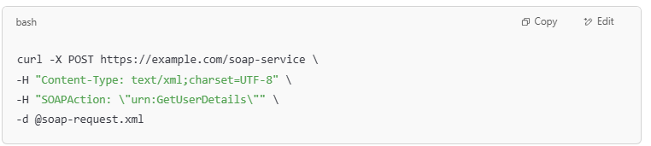
curl -X POST https://example.com/soap-service \
-H "Content-Type: text/xml;charset=UTF-8" \
-H "SOAPAction: \"urn:GetUserDetails\"" \
-d @soap-request.xml

soap-request.xml contains:
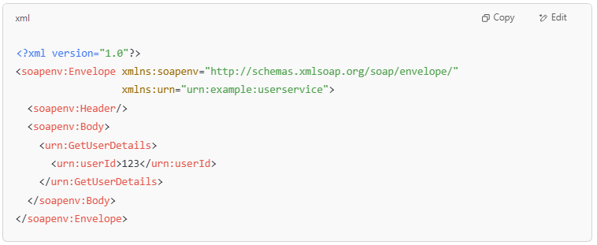
<?xml version="1.0"?>
<soapenv:Envelope xmlns:soapenv="http://schemas.xmlsoap.org/soap/envelope/"
xmlns:urn="urn:example:userservice">
<soapenv:Header/>
<soapenv:Body>
<urn:GetUserDetails>
<urn:userId>123</urn:userId>
</urn:GetUserDetails>
</soapenv:Body>
</soapenv:Envelope>

Sure! In SOAP (Simple Object Access Protocol), methods are actions defined in a WSDL (Web Services Description Language) file. These methods are like functions — they accept input parameters and return results.
SOAP messages are sent as XML envelopes using HTTP POST.

🧾 Structure of a SOAP Request:
# Source: AI Source: Provided by: [Data Path: Persons Table -> ID Column: 1, Name_En Column: Motasem Essam] -> From: [ChatGPT] on [1/19/2026]
Each method call is placed inside the <soapenv:Body> element in an XML envelope.
Here are examples of different SOAP methods (actions) using real-world-like operations.

📦 1. GetUserDetails
# Source: AI Source: Provided by: [Data Path: Persons Table -> ID Column: 1, Name_En Column: Motasem Essam] -> From: [ChatGPT] on [1/19/2026]
Purpose: Fetch user details by ID.
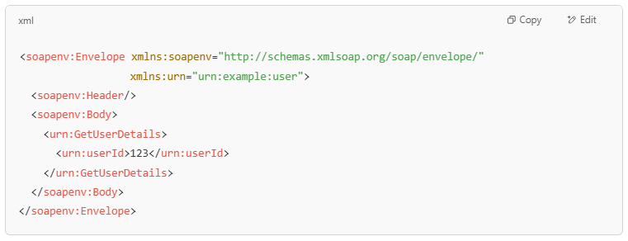
<soapenv:Envelope xmlns:soapenv="http://schemas.xmlsoap.org/soap/envelope/"
xmlns:urn="urn:example:user">
<soapenv:Header/>
<soapenv:Body>
<urn:GetUserDetails>
<urn:userId>123</urn:userId>
</urn:GetUserDetails>
</soapenv:Body>
</soapenv:Envelope>

📝 2. CreateOrder
# Source: AI Source: Provided by: [Data Path: Persons Table -> ID Column: 1, Name_En Column: Motasem Essam] -> From: [ChatGPT] on [1/19/2026]
Purpose: Create a new order with item details.
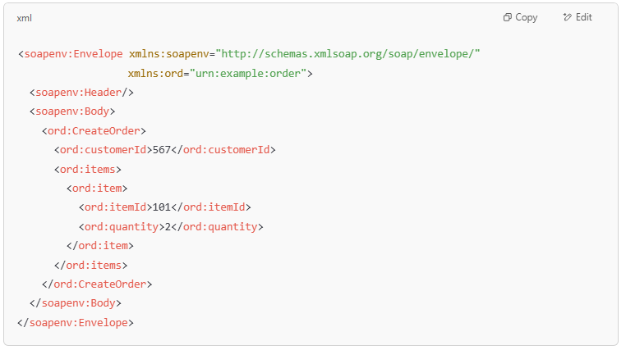
<soapenv:Envelope xmlns:soapenv="http://schemas.xmlsoap.org/soap/envelope/"
xmlns:ord="urn:example:order">
<soapenv:Header/>
<soapenv:Body>
<ord:CreateOrder>
<ord:customerId>567</ord:customerId>
<ord:items>
<ord:item>
<ord:itemId>101</ord:itemId>
<ord:quantity>2</ord:quantity>
</ord:item>
</ord:items>
</ord:CreateOrder>
</soapenv:Body>
</soapenv:Envelope>

🧾 3. GetInvoice
# Source: AI Source: Provided by: [Data Path: Persons Table -> ID Column: 1, Name_En Column: Motasem Essam] -> From: [ChatGPT] on [1/19/2026]
Purpose: Retrieve an invoice for a given invoice number.
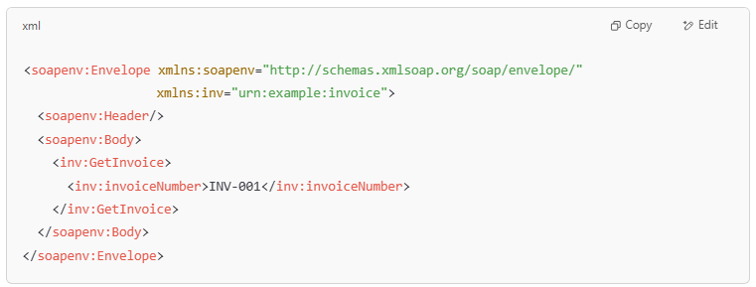
<soapenv:Envelope xmlns:soapenv="http://schemas.xmlsoap.org/soap/envelope/"
xmlns:inv="urn:example:invoice">
<soapenv:Header/>
<soapenv:Body>
<inv:GetInvoice>
<inv:invoiceNumber>INV-001</inv:invoiceNumber>
</inv:GetInvoice>
</soapenv:Body>
</soapenv:Envelope>

❌ 4. DeleteAccount
# Source: AI Source: Provided by: [Data Path: Persons Table -> ID Column: 1, Name_En Column: Motasem Essam] -> From: [ChatGPT] on [1/19/2026]
Purpose: Delete a user account by ID.
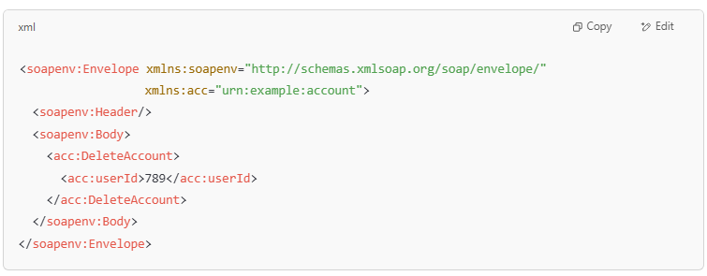
<soapenv:Envelope xmlns:soapenv="http://schemas.xmlsoap.org/soap/envelope/"
xmlns:acc="urn:example:account">
<soapenv:Header/>
<soapenv:Body>
<acc:DeleteAccount>
<acc:userId>789</acc:userId>
</acc:DeleteAccount>
</soapenv:Body>
</soapenv:Envelope>

✅ Sending These with cURL
# Source: AI Source: Provided by: [Data Path: Persons Table -> ID Column: 1, Name_En Column: Motasem Essam] -> From: [ChatGPT] on [1/19/2026]
Assuming you save the request in a file like soap-request.xml, you'd send it like this:
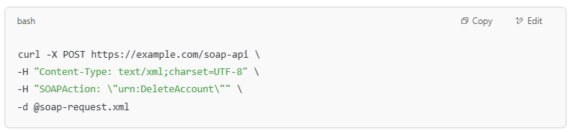
curl -X POST https://example.com/soap-api \
-H "Content-Type: text/xml;charset=UTF-8" \
-H "SOAPAction: \"urn:DeleteAccount\"" \
-d @soap-request.xml

cURL with GraphQL
# Source: AI Source: Provided by: [Data Path: Persons Table -> ID Column: 1, Name_En Column: Motasem Essam] -> From: [ChatGPT] on [1/19/2026]
Great! Using cURL with GraphQL is very doable — GraphQL APIs typically accept HTTP POST requests with a JSON payload.
Here’s a step-by-step guide with examples. 🔍

🧱 GraphQL Basics Recap
# Source: AI Source: Provided by: [Data Path: Persons Table -> ID Column: 1, Name_En Column: Motasem Essam] -> From: [ChatGPT] on [1/19/2026]
- You send a query or mutation inside a JSON object.
- The request is sent as POST to the GraphQL endpoint.
- The server returns JSON in response.

📌 General cURL Format
# Source: AI Source: Provided by: [Data Path: Persons Table -> ID Column: 1, Name_En Column: Motasem Essam] -> From: [ChatGPT] on [1/19/2026]
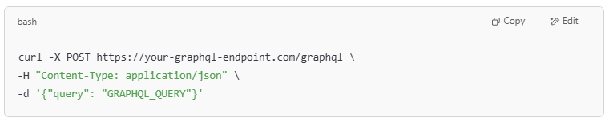
curl -X POST https://your-graphql-endpoint.com/graphql \
-H "Content-Type: application/json" \
-d '{"query": "GRAPHQL_QUERY"}'

✅ Example 1: Basic GraphQL Query (get user data)
# Source: AI Source: Provided by: [Data Path: Persons Table -> ID Column: 1, Name_En Column: Motasem Essam] -> From: [ChatGPT] on [1/19/2026]
GraphQL query:
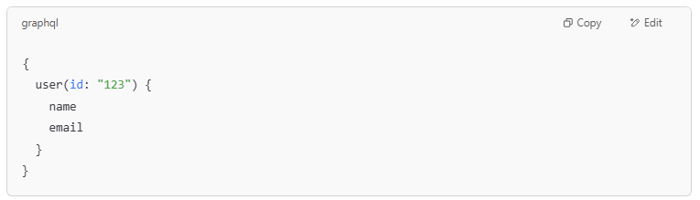
{
user(id: "123") {
name
email
}
}

cURL version:
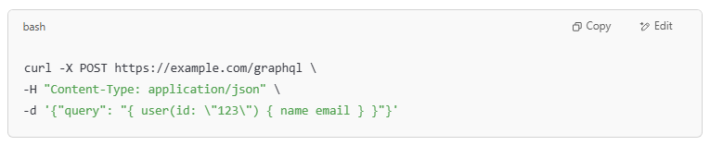
curl -X POST https://example.com/graphql \
-H "Content-Type: application/json" \
-d '{"query": "{ user(id: \"123\") { name email } }"}'

✅ Example 2: GraphQL Query with Variables
# Source: AI Source: Provided by: [Data Path: Persons Table -> ID Column: 1, Name_En Column: Motasem Essam] -> From: [ChatGPT] on [1/19/2026]
Query:
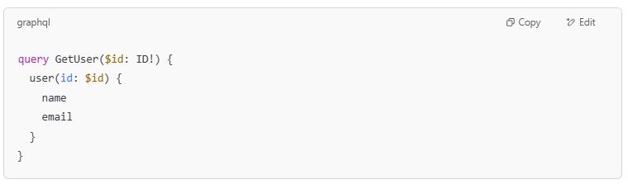
query GetUser($id: ID!) {
user(id: $id) {
name
email
}
}

Variables:
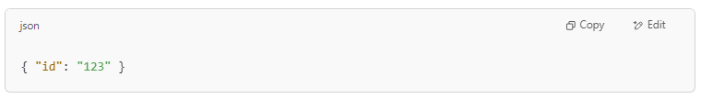
{ "id": "123" }

cURL command:
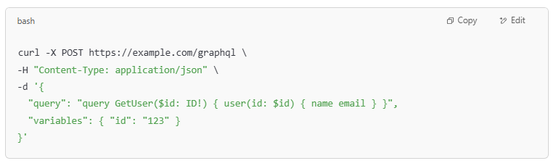
curl -X POST https://example.com/graphql \
-H "Content-Type: application/json" \
-d '{
"query": "query GetUser($id: ID!) { user(id: $id) { name email } }",
"variables": { "id": "123" }
}'

✅ Example 3: GraphQL Mutation (create a post)
# Source: AI Source: Provided by: [Data Path: Persons Table -> ID Column: 1, Name_En Column: Motasem Essam] -> From: [ChatGPT] on [1/19/2026]
Mutation:
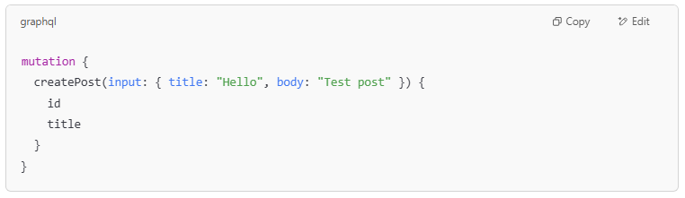
mutation {
createPost(input: { title: "Hello", body: "Test post" }) {
id
title
}
}

cURL:
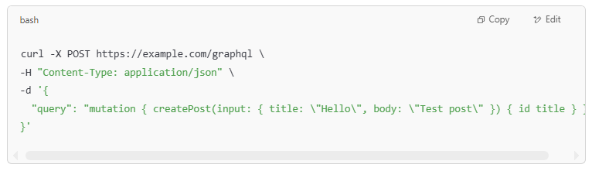
curl -X POST https://example.com/graphql \
-H "Content-Type: application/json" \
-d '{
"query": "mutation { createPost(input: { title: \"Hello\", body: \"Test post\" }) { id title } }"
}'

🔐 Optional: Adding Headers (e.g. Auth)
# Source: AI Source: Provided by: [Data Path: Persons Table -> ID Column: 1, Name_En Column: Motasem Essam] -> From: [ChatGPT] on [1/19/2026]
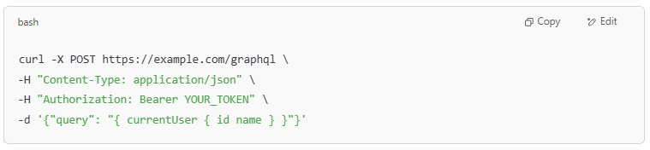
curl -X POST https://example.com/graphql \
-H "Content-Type: application/json" \
-H "Authorization: Bearer YOUR_TOKEN" \
-d '{"query": "{ currentUser { id name } }"}'

✅ Summary
# Source: AI Source: Provided by: [Data Path: Persons Table -> ID Column: 1, Name_En Column: Motasem Essam] -> From: [ChatGPT] on [1/19/2026]
Element | Role
-X POST | GraphQL usually uses POST
-H | Set headers like Content-Type
-d | Send query as JSON body

